BU481 Lecture Notes
Fall 2024
Section: M
Instructor: Brandon Van Dam
Prepared by: Daisy Ye

Table of Contents
Class 1 - Introduction 3
Class 2 - Setting Direction and Assessing Performance 7
Class 3&4 - Industry Analysis 14
Class 5&6 - Business Strategy and Competitive Advantage 22
Class 7&8 - Management Preferences and Strategy 29
Class 9&10 - Resources and Strategy 34
Class 11&12 - Organization and Strategy 39
Class 14 - Ratios Tell a Story (2021) 45
Class 16&17 - Strategic Choice 47
Class 18 - Strategic Execution 51
Class 19&20 - Corporate Strategy 59

Class 1 - Introduction
Strategic management is
- An ongoing process that evaluates and evolves a firm’s direction by
  - Assessing competitive env and setting goals
  - Determining and choosing b/w strategic choices
  - Regularly re-assessing implementation
  - Eval changing and newly emerging circumstances

Strategic management focus on the business as a whole
- Holistic approach that helps answer big questions on how to run a business
  - What are the best industries to be in
    - And how do you compete in the ones that are bad
  - What determines the total corporate performance of an entire business enterprise
  - Why do some businesses succeed and some fail
  - What can general managers actually do about it

Three big questions
- Where do we compete?
- How do we compete?
- How do we execute on this?

Diamond E
- Helps to organize your analysis and make it comprehensive
- Focus is on the integration of all relevant elements for a big pic view
  - Environment, strategy, management preferences, organization, resources & capabilities (with strategy at the centre)
  - Consistency and alignment
- All options and considerations should take into consideration for analysis

Diamond E model tensions
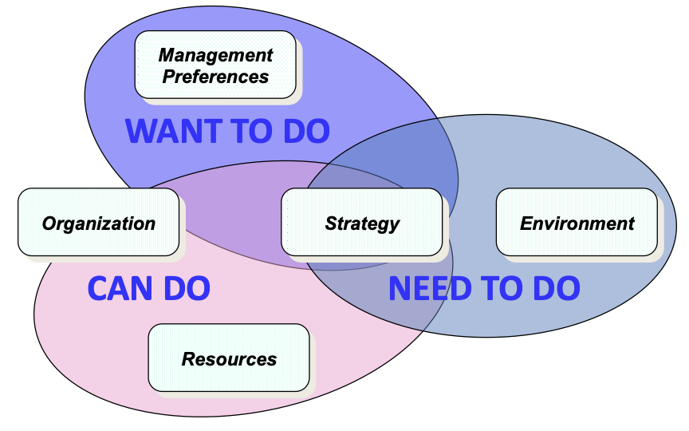

Strategic analysis process
- Issue identification
  - Start by recognizing the decision maker’s role in the case. CEO? VP?
    - It’s usually in the FIRST or LAST paragraphs
  - Clearly identify the key issues and problems in the company is facing as part of our assessment
    - Read intro and conclusion
    - Look for “was worried, concerned, wondering, considering”
  - Keep the identified issues front and centre as you move through the analysis, recommendation, and action plan
    - During the analysis, ask yourself: am I looking at all aspects of the issues?
    - At the end, ask yourself: does my recommendation and my suggested action plan truly address the issue? (burden of proof)
- External analysis
  - Is this a profitable industry to be in (porter’s five forces)
  - Who is gaining value in the industry (industry value chain)
  - What is going on in the industry (PEST)
    - Macroeconomic forces
    - What trends are happening that will impact the industry
  - What do firms need to do to win in the industry (KSF)
- Internal analysis: strategy
  - Value proposition (goals, product market focus, core activities, with value proposition in the middle)
  - Looking at the current state of the company
  - Question: how are we choosing to compete? Is there alignment? Is it working?
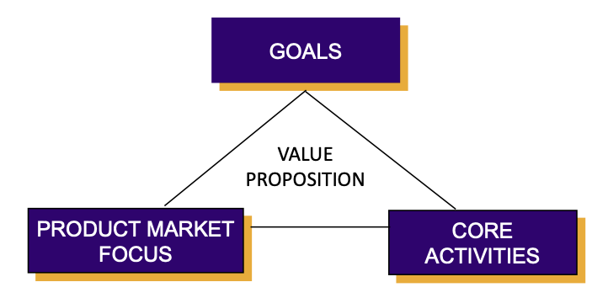
- Internal analysis: diamond e
  - Is there good alignment between eh elements or are there gaps?
  - What does the performance to date show? (qualitative and quantitative metrics)
  - What is the company’s competitive advantage? is it sustainable? Can it be easily copied?
  - Is there fit among all the elements?
- Financial analysis
  - Key financial ratios to track how well strategy is doing
  - Single year as well as year over year comparisons (focal firms)
  - Key ratios: revenue growth, net income growth, same store growth, EPS growth, ROE, ROA, ROS, current ratio, DE, inventory turnover
  - Good practice is to combine vertical and horizontal analysis
- Competitor analysis
  - Who are the main competitors and why?
    - Market share, brand, number of stores, geographic reach, history
  - How are they performing financially (compared to the focal firm)?
  - What resources/capabilities do they have
  - Do they have the ability to take away our competitive advantages?
- Strategic choices
  - Develop and analyze alternatives that are
    - Viable
    - Distinct
    - Listed in case and/or developed by you
  - Assess pros and cons thinking through all the aspects (strategic, financial, organizational)
  - Be careful that you are not already supporting a foregone conclusion
- Recommendation
  - Pick one of the options that you have previously developed
    - Your process is off if you recommend something that did not appear as an option before
  - Do NOT just reiterate the pros listed under your option to support your choice, but explain why you think that the pros for your choice outweigh those of the other options
  - Be upfront about the cons and discuss if and how you think that you can deal with them effectively
- Action plan/implementation
  - Who will do that?
    - Leadership and org readiness and style
  - What is the timeline of implementation?
    - Crisis curve, how staged?
  - How will the recommendation impact all of the different functional areas of the firm?
    - What are the priority areas for action?
- Risks and contingency plans
  - What are the risks with the proposed strategy?
  - What have or will you do to minimize the risk?
  - Contingency plan:
    - What will you do if the proposed strategic choice does not work?
    - Is there a plan B?

Class 2 - Setting Direction and Assessing Performance
What is strategic management?
- Ongoing process that evaluates and evolves a firm’s direction to create and sustain a competitive advantage
- Assesses competitive environment and sets goals
- Evaluates changing/newly emerging circumstances
General manager challenges
- Responsibility for all functional facets of organization
- Job is to create value for the enterprise
- Strategic decisions require the collective intelligence of the workforce
  - How do you engage them?
- Today’s focus
  - Assessing performance
  - Setting long term direction

Many different ways to assess performance
- Organizational health and operating performance (SAA - chap 1)
- Balanced scorecard

Qualitative assessment - is the strategy well-conceived?
- Covers all the bases?
- Internally consistent?
- Makes sense?
- Timely and in step with marketplace?
- Consistent with recent moves?

Quantitative assessment - what are the results?
- Is company achieving its financial and strategic objectives?
- Is company an above average industry performer?

Operating performance - quantitative measures of financial and market performance
Organizational health - qualitative and quantitative measures of operating performance

Asking yourself three questions
- Where was your business 3 years ago?
- Where is your business today?
- Which way is it currently moving?
Balanced scorecard
Ask four basic questions (in this order)
- Can we continue to improve and create value? Innovation and learning
- What must we excel at? Internal
- How do customers see us? Customer
- How do we look to shareholders? Financial

- For each of the four areas, create a few key goals (2-3) with measures attached to them
  - Leading and lagging measures
- Data related to the measures needs to be timely
- Compensation for managers should be directly linked to achievement of measures
- Must have ongoing support and involvement of senior management

Quantitative financial indicators
- Profitability ratios
- Liquidity ratios
- Financial leverages
- Asset turnover ratios
- Other - dividends, cash flow

Profitability ratios (higher is better)
- Gross profit margin
- Net profit margin
- ROA
- Return on stockholder’s equity
- Return on invested capital
- Return on sales
- EPS (growth)
Liquidity ratios
- Current ratio
  - Ratios should be higher than 1.0
- Quick ratio (acid test ratio)
- Working capital
  - Bigger amounts are (sometimes) better because company has more internal funds available
Financial leverage ratios
- Debt-to-Assets Ratio
  - Low fractions or ratios are better
- Debt-to-Equity Ratio
  - Should be around/less than 1.0
- Long-term Debt to Equity Ratio
  - Low ratios indicate greater capacity to borrow additional funds if needed
- Times-Interest earned (or coverage) ratio
  - Lenders insist on min of 2.0 but ratios above 3.0 signal greater creditworthiness
Asset turnover ratios
- Days of Inventory
  - Fewer days of inventory usually better
- Inventory Turnover
  - Higher is better
- Average Collection Period
  - Shorter collection time is better
Other ratios/financial metrics
- Dividend Yield on Common Stock
- Price/Earnings Ratio
- Internal Cash Flow
- Percentage of sales from new products
  - Particularly in high innovation-type industries such as electronics, pharmaceuticals, medical devices

Multi-year analysis
- Some general trends
  - Sales growing faster, slower, same pace as the market as a whole
  - Acquiring new customers while retaining existing customers
  - Profit margins increasing or decreasing
  - Net profits and ROI
  - Overall financial strength
  - Credit rating improving or declining
  - Continuous improvement in internal performance measures (days of inventory, unit costs)
- The stronger a company’s overall performance, the less likely for radical changes in strategy. Weak performance is almost always a sign of weak strategy, weak execution or both.

Setting direction
- Vision
  - Clearly communicate purpose of business
  - Strong sense of direction for the company and for strategy formation
  - Reinforce the day to day actions

Start strategy analysis with focus on vision (SAA, P6-7)
- Resolves confusions as to the purpose of the business
- Revitalize current vision
- Reinforce internal “sense of vision”

Vision - Collins & Porras Framework
Vision - guiding philosophy
- Values: basic beliefs that guide behaviour
- Core beliefs/purpose
  - Reason for being
  - Long-term (…many never be fully realized)

Mission - tangible image
- Clear, compelling, activating, stretch
- Can be visualized

Strategic vision vs mission
- A strategic vision concerns a firm’s future business path - where we are going
  - Markets to be pursued
  - Future product/market/customer/technology focus
  - Kind of company management is trying to create
- A company’s mission statement typically focuses on its present business purpose - who we are and what we do.
  - Current product and service offerings
  - Customer needs and customer groups being served
  - Geographic coverage

Payoffs of a clear strategic vision
- Crystallizes an organization’s long-term direction
- Reduces risk of rudderless decision making
- Creates a committed enterprise where organizational members enthusiastically pursue efforts to make the vision a reality
- Provides a beacon to keep strategy related actions of all managers on common path
- Helps an organization prepare for the future

Setting direction
- Vision “acid test” on usefulness
  - Desirable and feasible destination
  - Flexibility for management to get there
  - Stretch for organization to achieve
- Too often, vision statements are just PR

Class 3&4 - Industry Analysis
Defining the industry
- Two dimensions
  - Products/services offered?
  - Geographic scope - global, local, regional?
- Are the forces (rivals, suppliers, buyers) the same?
  - If the industry structure for two products is different than it may be better to look at them as different industries
  - If two or more forces are different than potentially different industries
- It is a matter of judgment

Key questions regarding the industry and competitive environment
- What are the industry’s dominant economic traits?
- How strong are competitive forces?
- What forces are driving change in the industry?
- What market positions do rivals occupy? What moves will they make next?
- What are the key factors for competitive success?
- How attractive is the industry from a profit perspective?

Industry analysis objectives
- Understand where value is being derived in the industry
- Understand drivers of profitability
- Understand why some industries are more attractive than others
- Understand macroeconomic influences/trends
- Understand KSFs

Industry analysis tools
- Industry value chain / value system
- Porters five forces model
- PEST(EL)
- KSF
- Game theory
- Scenario planning
- New economy models
- Global industry status

Industry value system (External)
- A chain of activities/steps that links raw materials through to the final product being delivered
- Objective is to add value at each step
  - Each activity in the chain has revenues, costs, and profits
- Usually, a firm performs a limited number of activities in the value system
  - The more activities they perform, the greater control they have

Value system: vertical integration (backward & forward)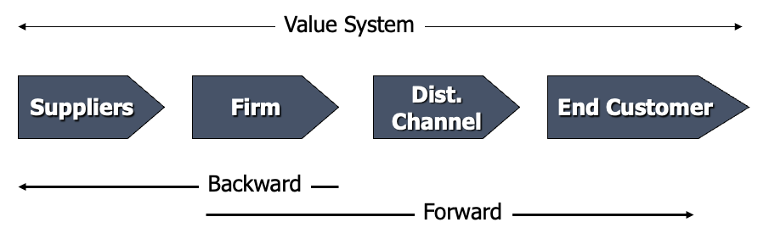

Value system analysis
- Any activities the company should leave to others in the chain (e.g. divest)?
- Any activities that the company should integrate forward or backward?
- How to achieve competitive advantage in the industry given the activity’s unique cost drivers?
- Profitability at each stage indicates power/importance of that value system stage

Industry vs firm value chain
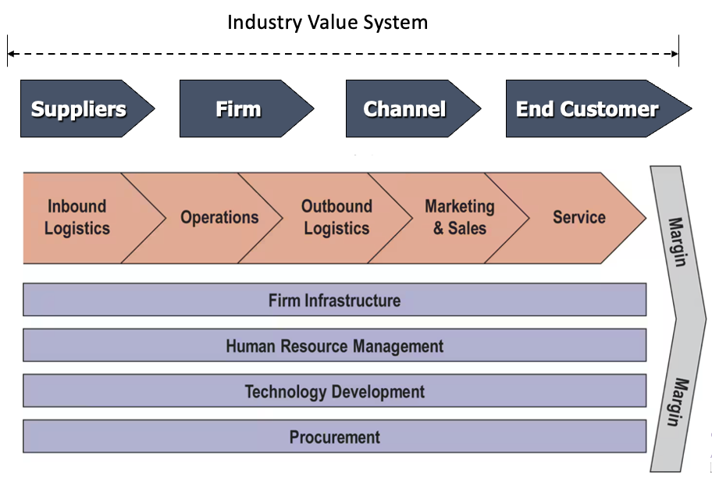
Why the value system and the value chain matter?
- The values created by a system and the chain are measured by what the consumer/end users pays
- This value covers all costs and provides all profits to those in the chain
- Different chain may receive different values
- Helps determine what part of the value system you want to be

Porter’s five forces model
- Industry structures has a strong influence in defining the rules of the competitive game as well as the strategies available to the firm
- Industry structure can shift gradually over time… competition continually works to drive down the rate of return on invested capital

The five forces
- Threat of entrants to industry
- Buyers to industry
- Suppliers to industry
- Substitutes to industry
- Rivalry within industry
- Collective strength of forces determines ultimate profit potential of an industry
Threat of new entrants
- Brings in new capacity and desire to take market share -> puts a cap on profits
- Based on
  - Height of barriers of entry
  - Potential response by incumbents
- Depends if you are already in the industry or not

Barriers to entry
- Supply side economies of scale
- Demand side economies of scale
  - Network effects
- Customer switching costs
- Access to distribution channels
- Capital requirements
- Incumbency advantages
  - Proprietary technology
  - Cost or quality advantage not available to potential entrants
  - Access to raw materials
  - Brand
  - Learning/experience
- Government policy
- Expected retaliation

Substitutes
- One kind of good (or service) is said to be a substitute good for another kind insofar as the two kinds of goods can be consumed or used in place of one another in at least some of their possible uses
- Always present - but sometimes easy to overlook
- Threat is high when
  - Substitute offers an attractive price-performance trade-off compared to the industry
  - Switching costs are low
  - Be aware of changes in other industries that may impact your industry

Suppliers
- Powerful suppliers can capture more of the industry profits
- What influences this threat?
  - Concentration relative to industry it sells into
  - Switching costs
  - Importance of industry to supplier
  - Supplier’s products are differentiated
  - Possibility of forward integration

Buyers
- Powerful buyers can capture more of the industry profits
- What influences this threat?
  - Concentration – Large or small volumes
  - Level of product standardization
  - Product represents significant portion of final product cost (more sensitive)
  - Buyers earns low profits (more sensitive)
  - Product unimportant to final product quality
  - Credible threat of backward integration

Rivalry
- Number of competitors is high and/or of equal size
- Industry growth is slow
- Differentiation / switching costs
- Exit barriers are high
- Rival are committed to the business
- Depends on intensity and dimensions of competition
- If firms compete on the same dimension, for example price, then rivalry is likely high
- Competing on price more likely when
  - Fixed costs are high
  - Capacity can only be extended in large increments
  - Product is perishable
- Other dimensions include quality, service, features, etc
  - These can improve value for customers
  - Defend against substitutes

Industry analysis
- Industry attractiveness is a function of the strength or weakness of these forces
- Forces jointly determine the competitive intensity and profitability
- Not all forces have the same impact
- Strongest forces more crucial to strategy formation
  - Up to 10% of profits can be explained by industry

Common pitfalls
- Making lists instead of conducting deep analysis
- Treating all forces equally rather than identifying which ones are important and digging deeper into those
- Doing a static analysis - ignoring trends
- Using the analysis to declare the industry as attractive/unattractive - rather than using the analysis to guide strategic choice

PEST analysis (environment)
- Assess the macro-economic forces that determine the context within which the industry operates
- Political, economic, social, technological, (environmental and legal)
- Source of further current or future change in industry
- These changes will lead to changes for all businesses in the industry

Thinking strategically about a company’s macro-environment
- Diagnosing a company’s external situation involves assessing strategically important factors that have a bearing on the decisions a company’s makes about its
  - Direction
  - Objectives
  - Strategy
  - Business model
- Requires that company managers scan the external environmental to
  - Identify potentially important external developments (opportunities and threats)
  - Assess their impact and influence
  - Adapt a company’s direction and strategy as needed

Porter’s & PEST models
- How do these forces impact threat of entry, buyer power, supplier power, substitutes, and rivalry?
- How will these shift given the PEST forces

Key success factors (industry)
- Dictated by industry characteristics
- All firms in an industry must possess them in order to be viable
  - Table stakes
  - Allow a firm to compete in an industry
- Airline industry example: gate access, airplanes, pilots, meeting safety standards
- Great companies figure out how to KSF

Key success factors (industry) - how to identify?
- What do customers want? What basis do they use to choose between different offerings?
  - E.g. supermarkets: customers may want lower prices -> capabilities to increase efficiency, reduce costs
- How does the firm survive competition?
  - What drives competition?
  - What dimensions do firms compete on?
  - How can one obtain an advantageous competitive position?
  - E.g. High-end smartphones compete on features -> solid R&D capability
- Derived from your IVC, Porter, and PEST analysis

Link between industry/environment - strategy
- Need to understand link between profit and industry
  - Profit model (fixed cost structure, variable cost structure, breakeven point, upfront costs, etc)
- Need to understand time horizon
- Need to understand supply and demand in industry
  - Technology, competition for inputs, needs and preferences of buyers
- Need to understand competition in industry
  - Aggregate and individual competitors
- Need to understand influence of external forces

Class 5&6 - Business Strategy and Competitive Advantage
Strategy explains:
- How the organization intends to compete and succeed in the marketplace
  - Way to translate general ideas about direction into actionable terms
- Creation of a unique and valuable position involving the combination of a different set of activities
- Expression of how the org can be unique in a way that can’t be imitated by competitors
- Strategy provides the firm with its overall direction, aimed at achieving sustained, superior performance over the long run in a competitive marketplace

What is strategy - Michael porter
- NOT operational effectiveness
  - Leads to imitation and homogeneity in most casts
- Rests on unique activities
  - Being different than competitors
  - Combining activities in different ways creating a strategic fit
    - Simple consistency
    - Reinforcing activities
    - Optimization of effort
- Sustainable strategy requires trade-offs
  - Cant be all things to all people
- Creating a clear strategy often dependent on leadership
  - Requires constant discipline and clear communication

Elements of a business strategy
- Goals
  - What does the business propose to achieve or where it intends to go?
- Core activities
  - What are the primary value-adding activities that the business intends to perform?
  - How does it intend to perform them?
- Product market focus
  - What are the products/services that the business plans to sell, and to what specific markets?
- Value proposition
  - How does the business intend to attract customers
  - What benefits are the company offering to the marketplace?

Elements of a business strategy
- Goals, product market focus, core activities
  - Value proposition in the middle
- Analysis: degree of linkage and coherence between the elements
Goals
- An expression, in measurable terms, of what a business intends to achieve or where it intends to go
- Absolute and relative to competition
- Provide targets against which progress, and performance can be assessed
- Can be different time frames
- Hard goals (financial) vs soft goals (social)
- Growth, harvest, or divest
** need to determine goal priorities, not just create a list **

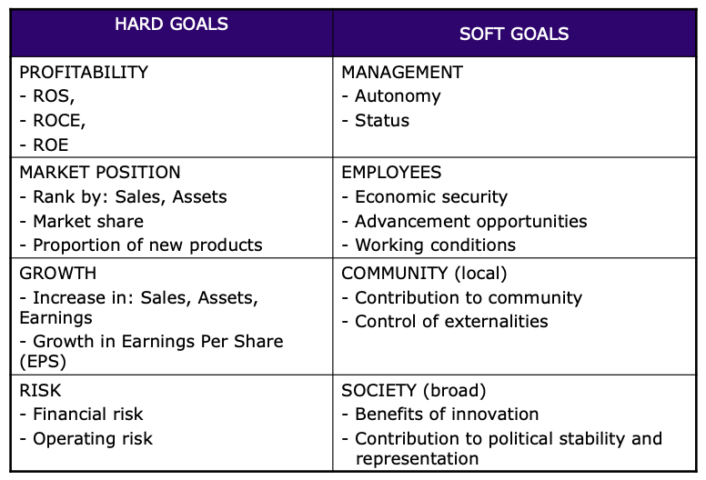
Product market focus
- What the company is providing to whom, where
- Provides clarity around which products/services and markets are the priority currently and in the future
- Risk level
- Ansoff matrix

Core activities
- Activities that are critical to the effectiveness of the operation of the business
- Activities within the firm that add value
  - Contribute directly to the value proposition
  - Need to distinguish between necessary activities and those that add value
- Highlights the key jobs that will have to be done and the capabilities that will need most to be developed and reinforces
  - What shouldn’t be outsourced
  - Related to others in industry value system (vertical integration = control)
Value proposition
- A statement of the fundamental benefits that the company has chosen to offer in the marketplace
- Generic strategies (porter)
  - Low cost, differentiation, best cost provider, stuck in the middle
- Value proposition can create a competitive advantage when it is hard for the competition to match/copy
  - Stick with clear, simple themes that are understandable to the customer
  - Can be groups of different customers with different values propositions (universities)

Value proposition examples
Walmart business strategy
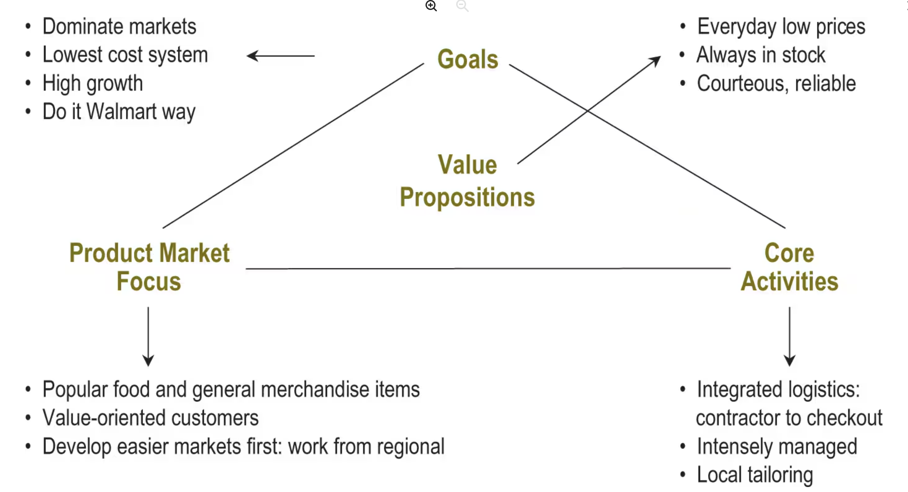
Generic competitive strategies
- Low cost strategy
  - Broad vs focused
  - Firm provides products/services at lower price than the competition in order to compete on price
- Differentiation strategy
  - Broad vs focused
  - Firm sets itself apart from competition through something different (product features, service, quality)
- Best-cost provider (integrated) strategies
- stuck in the middle

low-cost provider strategies
- make achievement of meaningful lower costs than rivals the theme of firm’s strategy
- include features and services in product offering that buyers consider essential
- find approaches to achieve a cost advantage in ways difficult for rivals to copy or match
- low-cost leadership means low overall costs, not just low manufacturing costs or production costs

approaches to securing a cost advantage
- do a better job than rivals of performing value chain activities efficiently and cost effectively
- revamp value chain to bypass cost-producing activities that add little value from the buyer’s perspective

Differentiation strategies
- objective: incorporate differentiating features that cause buyers to prefer firm’s product or service over brands of rivals
- keys to success
  - Find ways to differentiate that create value for buyers and are not easily matched or cheaply copied by rivals
  - Keeping the cost of achieving differentiation below the higher price that can be charged

benefits of successful differentiation
- A product / service with unique, appealing attributes allows a firm to:
  - Command a premium price and/or
  - Increase unit sales and/or
  - Build loyalty

Types of differentiation
- Unique taste (Dr Pepper)
- Multiple features (Microsoft Office, iPhone)
- Wide selection and one-stop shopping (Home Depot, Amazon)
- Superior service (FedEx)

Best-Cost provider strategy
- Low-cost operations + differentiation
- To be a best cost provider, a company must be able to
  - Incorporate attractive features at a lower cost than rivals
  - Manufacture a good-to-excellent quality product at a lower cost than rivals
  - Still get a price premium for the product
  - Develop a product that delivers good-to-excellent performance at a lower cost than rivals
  - Provide attractive customer service at a lower cost than rivals

Risk of a best-cost provider strategy (stuck in the middle / black hold strategy)
- A best-cost provider may get squeezed between strategies of firms using low-cost and differentiation strategies:
- Low-cost leaders may be able to siphon customers away with a lower price
- High-end differentiators may be able to steal customers away with better product attributes
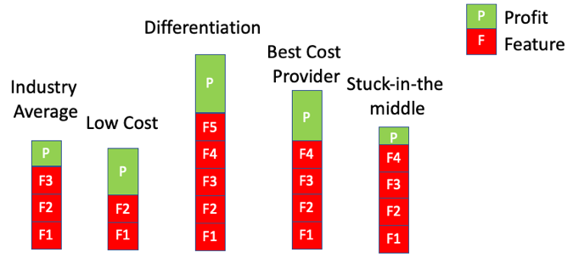

Focus Cost Leadership
- Requires competing based on price to target a narrow market
- Charges low prices relative to other firms that compete within the target market
  - Claire’s sells cheap jewellery to young girls/teens
Focus Differentiation
- Requires offering unique features that fulfill the demands of a narrow market
- Customized products to niche markets (although can lead to high sales)
  - Breezes Resorts – 7 high end resorts for couples without children
  - Harley Davidson – large motorcycles known for power
  - Whole Foods – high end, natural and organic produce

Business strategy: assessment steps
- How are you choosing to compete?
  - Low cost vs. Differentiation
- Do the four elements complement and reinforce each other?
  - Clarity, Logical, Coherence
- Does the value proposition resonate in the target market?
- Does the Business Strategy fit with the other elements of the business?
  - Organization, Resources, Management Preference, and Environment

Class 7&8 - Management Preferences and Strategy
Diamond E Framework: Tensions

Value distribution
- General managers responsible for
  - Value creation
  - Value capture
  - Value distribution
- Once value is created and captured
  - How is it distributed among stakeholders?
    - Shareholders, customers,

Reconciling stakeholders interests
- Employees
  - Fair (or higher) wages for their efforts
  - Specialized skills
- Customers
  - Desired features at the lowest possible price
  - Small customer pool can wield power
- Shareholders
  - Fair (or higher) return on their investment
  - Dependent on risk
- Suppliers
  - Work with the firm and get fair treatment
- Communities
  - Firms contribute to local communities
- Other stakeholders
  - Creditors, retirees, government, society

Management breaches
- Management can act in their own self interest
  - Agency theory (Enron case)
- Corporate governance (boards of directors)
  - Ensure strategic direction of the organization is in the best interest of the corporation (shareholders)
  - Monitor management behaviour
  - Ethical breaches may not be so easy to catch (bad judgement, asymmetric information)
  - Checks and balances
    - Align compensation with desired actions (e.g. stock options)
    - Penalize for breaches (e.g. firing, reputation)

Ways to address governance issues
- Board members must be experts
- Board meeting procedures should focus on the future, not just the past
- Board members need better access to information
- Board members need the time to devote to the corporation
- Board members must have the right incentive
- Board members must have strong leadership character

Management preferences
- Management preferences formed by the interaction of personal attributes, beliefs, character, and job context/situational pressures, career trajectory
- Management preferences are specific to their individual personalities, experiences, and situations
- Differences in personal preferences lead to differences in their strategic preferences lead to differences in organizational strategies

Personal attributes
- Personality traits
  - Big Five - Openness, Extraversion
- Basic needs
  - Central aspects of a manager’s personality
  - E.g. need for achievement, power, security, recognition
- Stable, enduring, generally consistent
- Fundamental influences on strategic preference

The indirect role of management preferences
Character - dimensions
Character and judgment
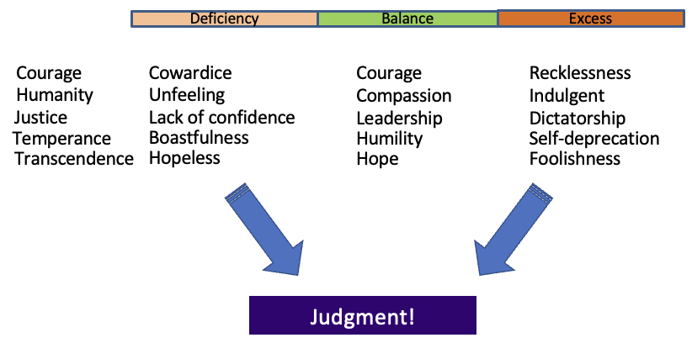

Competencies
- Information gets filtered and analyzed based on one’s competencies
  - People don’t know what they don’t know
- Character and competencies closely linked
  - Supports development and competencies

Job context
- Define the scope and nature of manager’s responsibilities, performance assessment, and rewards
- Formal and informal relationships
- Job definition (what you do) and job relations (expectations of others on you)
- Situational pressures

Frozen preferences
- Deeply held beliefs that can only be changed with great difficulty
- Individual views are embedded in a personal history
  - Facts are interpreted through one’s lenses
  - Can lead to differences on how information is interpreted

How to do a management preferences analysis?
- Develop and analyze the strategy
- Identify required management preferences
- Test the strategy - management preferences link
  - Compare required preferences with observed preferences
- Develop gap-closing analysis
  - Assess feasibility of closing any material gaps
  - If costs, chances of successes acceptable, carry the proposal forward
  - Potentially change management
- Move to next step of diamond-e analysis

Management preferences examples
- Companies
- Teams
- Governments
- Organizations
  - Universities

Class 9&10 - Resources and Strategy
Dual role of company resources
- Fuel - assets required for business to function
- Potential sources of strategic competitive advantage
Resource types
- Tangible
  - Marketing (ads)
  - Operations (factory)
  - R&D
  - Financial (capital)
  - Human
  - Locations
- Intangible
  - Brand
  - reputation
- Organization capabilities
  - Routines
  - Processes
  - Abilities
  - Culture
What are strategic resources?
- Non tradable assets which develop and accumulate within the firm [and which are valuable in the industry]. Such assets defy imitation because they have a strong tacit dimension and are socially complex.

Source of advantage
- Competitive advantage, whatever its source, can ultimately be attributed to the ownership of a valuable resource that enables the company to perform activities better or more cheaply than competitors
- Superior competitive performance will therefore be based on developing a competitively distinct set of resources and deploying them in a well-conceived strategy

General manager - resources management
- Key questions
  - What opportunities exist for economizing on the use of resources?
  - What are the possibilities for using existing asset more intensely and in more profitable ways?
- Four key tasks of manager related to resources
  - Finding / investing in resources
  - Upgrading resources
  - Leveraging resources
  - Efficient usage of resources

What is a resource-based strategy?
- Companies with competitively valuable resource strengths and competencies often deploy these capabilities to
  - Boost the competitive power of their overall strategy
  - Bolster their position in the marketplace
- Resource-based strategies
  - Attempt to exploit company resources to offer value to customers in ways rival cannot match
  - Can focus on eroding the competitive potency of a rival by developing different resources that effectively substitute for the strengths of the rival

Keep industry/context in mind
- A resource that is valuable in a particular industry or at a particular time might fail to have the same value in a different industry or chronological context

Why is the resource-based view (RBV) useful?
- Internal perspective of firm
  - Industry analysis only tells us so much!
- Way of explaining why some competitors are more profitable than others
- Explains why some industries are hard to enter (and exit)
- Suggests how to put idea of core competencies into practices
- Helps develop strategies that make sense depending on what you already have/can get

“Barney” Strategic Resources Test (VRIO)
- To be the basis for sustainable competitive advantage, a “resource” must pass 4 tests
  - Value
    - Context or industry dependent
  - Rarity
    - If common resource is at best a necessary entry ticket but not a source of competitive advantage
  - Inimitability (difficult to imitate)
    - May arise as a result of history, or many small decisions, or because of social complexity
  - Company organized
    - If organization does not exploit the resource - no value!
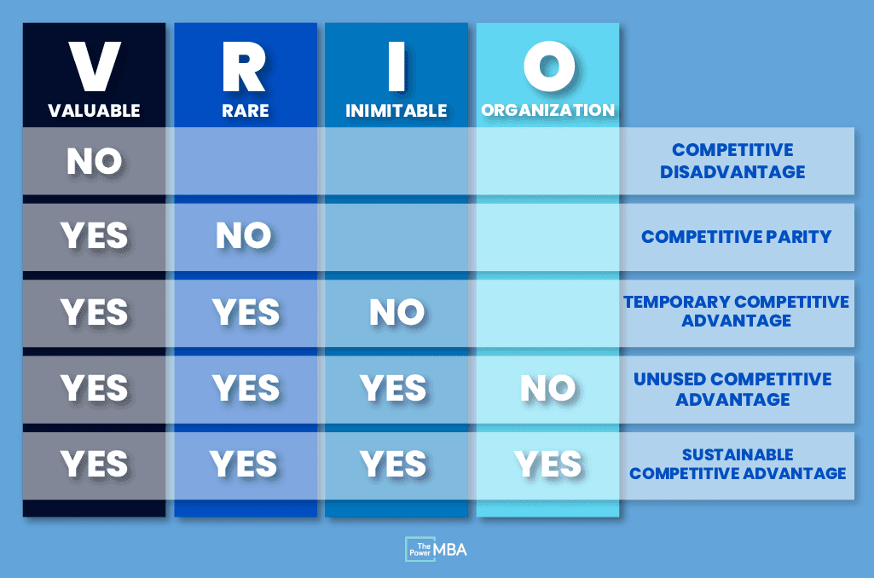

When are resource strategically valuable?
- It is hard to copy
- It depreciates slowly
  - Can it sustain a competitive advantage over time?
- Your company (not employees, suppliers, or customers) controls its value
  - Who is capturing the value created?
- It cannot be easily substituted
- It is better than competitors’ similar resources
  - Firms have to be honest about this (distinctive competence)
What makes a resource hard to copy?
- Physical uniqueness (mineral rights, great locations, pharmaceutical patents)
- Path dependency (Gerber baby products)
- Causal ambiguity
  - Unclear what it actually creating that advantage as it is usually a combination of things
- Economic deterrence
  - Usually sizable investment in an asset

How to do resource analysis
- Develop / analyze the strategy
- Identify resource / capability requirements for strategy
- Test the strategy - resource link
  - What do we have vs what do we need?
- Develop gap-closing analysis
  - What do we need to get?
  - How hard will that be? What is the timeline?
- Move to next step of diamond-e analysis

Step #2 and #3 - analysis by strategy triangle component
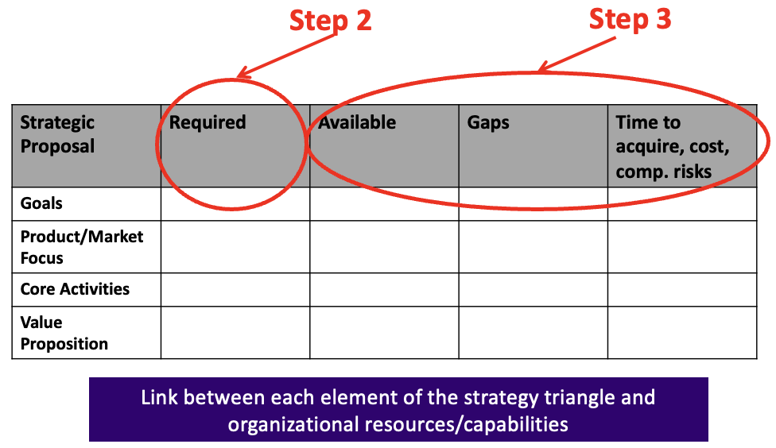

Step #4 - gap analysis
- Think through:
- What do we need to get?
- Additional costs
- Probability of success
- The costs of failure
  - What happens if we can’t implement the strategy?

Value Chain Analysis (Internal)
- Determine corporate (shared) resources
- Identify functional areas of company
  - Often core activities from strategy triangle analysis
  - Usually some combination of R&D, design, sourcing, marketing, operations, distribution, retailing
- Link resources to functional areas
- Identify competitive resources/capabilities
- Compare any competitive resource/capability identified to overall strategy

Internal Value Chain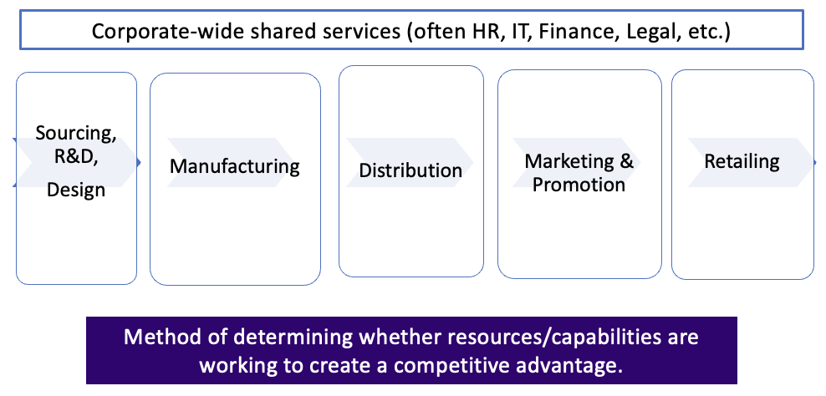

Class 11&12 - Organization and Strategy
Organizational levers to support strategy
- Organizational structure
- Management processes
  - Decision-making processes
  - Operating processes
  - Performance measurement & reward processes
- Leadership behaviour

Organizational structure
- Determines how information and influence flow through the hierarchy
- There are always trade-offs
- Typical options on how an organization can be structured
  - Functional
  - Product
  - Geographic
  - Employee-centric - holocracy (Zappos)
  - Matrix

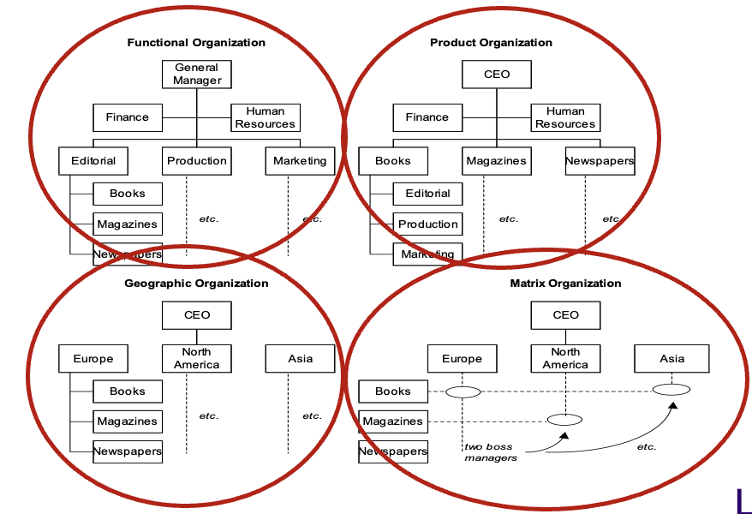
Align as much possible required capabilities based on proposed strategy with organization’s structural characteristics.

Low-cost strategy
- Commodity products
- Price competition

Centralized organizational process
- Organization structure
  - Efficiency
  - Economies of scale and scope
  - Standardization, volume, repetition of work
  - Lack of duplication of resources
  - Often functional structure
Differentiation strategy
- Product 1 (high end)
- Product 2 (high end)

Decentralized organizational process
- Organization structure
  - Two divisions
  - Self-contained with different resources and capabilities
  - Minimum centralized staff
  - Often product structure
Management processes
- Decision-making
  - Speed vs. accuracy
  - Diversity vs. predictability
- Operating
  - Cross-unit communication and cooperation
- Performance measurement and reward (motivation)
  - Team or individual
  - Quantitative vs. qualitative

Theory X
- Organizational objectives can be reached best by control, coercion, direction, threat, and financial rewards.
Underlying projection of the human being:
- People dislike work and prefer to avoid it
- Humans prefer to be directed over having responsibility
- Striving for security as overarching goal
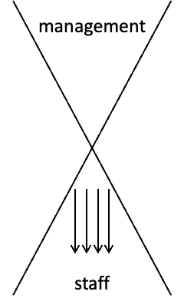
Theory Y
- Putting effort in work is as natural as playing or resting.
Underlying projection of the human being:
- People will direct themselves when they are committed to the objective of the organization
- Satisfaction with a job will result in commitment to the organization
- People strive for responsibility and personal achievements
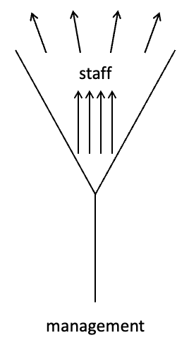

Leadership behaviour
- Cooperation or individual brilliance?
  - Elon Musk (Tesla)
  - Bob Deluce (Porter Airlines)
- Is behaviour consistent with the talk?
  - Costs reductions but executive perks

Behaviour & culture
- Behaviour
  - Observable:
    - How much energy employees put into job
    - How they manage subordinates
    - How employees relate to each other etc.
- Culture
  - Shared values, beliefs and core basic assumptions
    - Organizational way to “think and act”
    - Widely shared and strongly felt

How to change: organizational capabilities model
Leverage points for change (Macro Perspective)
- Organization structure
- Management processes
- Leadership behaviour

Analysis: strategy-organization link
- Complete the business strategy
- Identify the organizational elements (structure, processes, leadership behaviour) required to implement strategy
- Determine current organization elements; Identify gaps
- Determine how to bridge strategy-organization gaps and assess feasibility
  - What will it take to do this?
  - How much is it going to cost?
  - How long is it going to take?
  - How will it impact organizational culture/behaviour?
- Move to the next link in Strategy-Diamond E (or stop if you are now done!)

Organization & Strategy
Two Options (Diamond-E)
  - Organizational elements are modified to support the chosen generic strategy and business strategy
  - Generic strategy and business strategy are chosen to match the organization’s characteristics and environment requirements

Class 14 - Ratios Tell a Story (2021)
Variations in Financial Results
- Nature of the industry
  - PPE requirements
  - R&D requirements
  - Inventory turnover: perishable vs. non-perishable products
- Company’s management philosophy and policy
  - Manufacturing capacity; just enough vs. built for growth
  - Debt vs. equity
  - Organic vs. inorganic growth
    - Growing internally vs. mergers and acquisitions
- Management capability
  - Better management teams
- Macroeconomic trends
  - Some industries more influenced than others
    - FX rates, IR, tariffs, trade agreements, etc.
    - Cyclicality, dependent on weather
  - Industry life stage
  - % domestic vs. international operations

Financial Metrics: Profitability and Liquidity
• Revenues: Total money generated from normal business operations
• Gross Profit Margin: Net sales – COGS
- More useful metric than revenues
• Net Income: Profit that remains when all expenses and costs have been subtracted
from revenues
- Even more useful metric than GM
• ROA: Net income/Total Assets
- Could see a bump if you sell off assets, or if you are not an asset heavy industry
• ROS: Net income/Net Sales
- Could see a bump if net income is the same (become more efficient) while sales go down
• ROE: Net income/Total Equity OR ROA x Financial Leverage (see next page)
- Should be trending up or at least stable
- Can see a bump if total equity goes down

Financial Metrics: Leverage & Other
• Financial Leverage (from case): Total assets/Total Owners Equity
• Debt/Asset: Total Liabilities/Total Assets
- What percentage of a company’s assets are financed by debt rather than equity (how has a company growth and acquired assets over time)
- Assesses company’s liquidity (ability to meet short-term financial obligations)
• Debt/Equity: Total Liabilities/Total Shareholder’s equity
- Amount of debt a company has relative to its equity
- Assesses company’s solvency (ability to meet long term financial obligations)
- Control
• Asset Turnover: Net Sales/Total Assets
- High ratio means assets used effectively.
- Or significant number of sales being created with small number of assets
- Or company has begun to outsources activities after selling off equipment
• R&D Ratio: R&D Expense/Net Sales
- Expect in industries like pharma and technology
• Dividend payout: Cash dividends/Net Income
- Look to see if companies even giving out a dividend. Why would they do this?

Class 16&17 - Strategic Choice
Strategic choice and execution
- Identifying strategic problems
- Assessing strategic opportunities
- Deciding what changes in strategy
- Picking an option
- Implementing change

Evaluating strategic alternatives (two methods)
Method #1: article “evaluating strategic alternatives”
5 evaluation criteria tests (day framework)
- How attractive is the market opportunity?
- How sustainable are the competitive advantages?
- What are the prospects for successful implementation?
- Are the risks acceptable?
- Will the financial forecast results be achieved and increase shareholder value?

Test #1: how attractive is the market opportunity?
- Profitability of industry (external analysis)
  - Intensity of existing competition
- Events/trends in macroeconomic environment (PEST)
- Market size and growth
- Cyclicality of market demand
  - Is there big fluctuations in demand?
- Degree of market fragmentation
- Ease of channel access
  - Cost of acquiring customers/suppliers
- Barriers to entry

Test #2: how sustainable is the competitive advantage?
Law of Nemesis: nothing good lasts indefinitely
- Which of your current advantages yields a price premium (through differentiation) or (overall) cost leadership?
- Will the proposed strategy enhance these advantages or create new ones?
- How difficult will it be for competitors to imitate these advantages and how long will it take?

Potential barriers to imitation
- Supply side barriers (internal to company)
  - Distinctive capabilities
  - Proprietary technology
  - Economies of scale/scope
  - Backward integration ability
- Demand side barriers (link to market)
  - Customer and channel relationships
  - Brand equity

Test #3: prospects for successful implementation
- Feasibility
  - Does the business have the necessary skills and resources (financial, physical, access to tech, capabilities etc)? can you get them?
- Supportability
  - Do the key implementers understand the strategy and are they committed to it?
- Consistency
  - Is the strategic option consistent with your previous analysis? Does it solve the problem?

Test #4: are the risks acceptable?
- Assess risk
  - How robust are the strategic alternatives?
  - What are the assumptions underlying choices?
  - Sensitivity analysis (e.g. demand shift)
- Environmental uncertainties
  - Will target market react as anticipated?
- Internal uncertainties
  - Can the org implement the proposed strategy?
  - Overconfidence, management bias
- How are you going to manage identified risks
- What is your contingency plan in case the strategic option does not work?

Test #5: will financial results be achieved?
- Not all options offer the same potential returns
  - Timing (ROI takes longer)
  - Overall revenues not as much
  - Different cash flows
- Managing shareholder and customer risk/demands
- Test robustness of financial projections
  - Low/high scenarios
  - How could they be impacted by identified risks

Method #2: “what, why, how, risks, time” framework
- What are the details of the strategic option?
- Why would you want to pursue it?
  - External/internal/competitive reasons
- How are you going to implement it?
  - What would need to change internally to make it work?
  - Consider all key activities of the business
- What are the risks involved?
  - How will you address them?
- How much time will each element take?
  - Short, medium, long term
- Compare each element for each stratefic option being considered
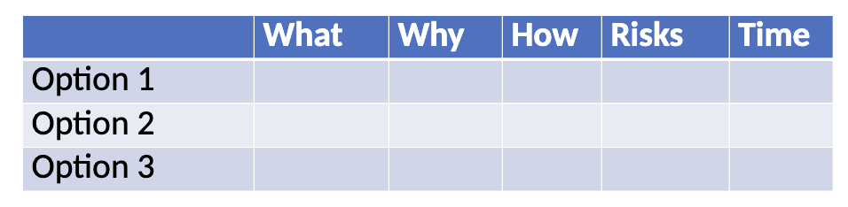

Decision Criteria
- Use criteria that are important to the company and help to address the issue
- Mutually exclusive, collectively exhaustive

Class 18 - Strategic Execution
For the chosen strategic alternative, need to assess and decide on:
- What needs to change and be added?
- Organization and employees ready for change?
- What should be the best sequence for the required changes?
- What style is most appropriate for the manager tasked to implement the changes?
- Who should lead the change process?

Creating a change plan
- Change plan unique to the situation based on needs and starting conditions
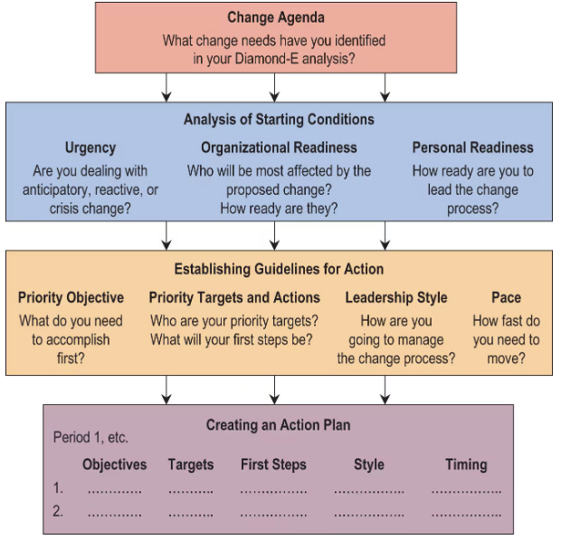
Step 1: Identify changes required: Change Agenda
Step 2: Identify starting conditions:
    - Urgency
    - Organizational readiness
    - Personal Readiness
Step 3: Establish guidelines for action:
    - Priority Objectives
    - Priority Targets and Actions
    - Leadership Style
    - Pace
Step 4: Creating an Action Plan

Step #1: change agenda
Identify all required changes in:
- Resources
- Organization
- Management preferences
After having identified all the changes required to support the preferred strategic alternative, segregate behavioural change from non-behavioural changes.
Identify likely leverage point to implement the behavioural changes
- Leadership
- Org structure
- Management processes
Step #2: identify starting conditions
- Three dimensions to access
  - Urgency
    - Pressure to implement the required changes
    - Function of performance, health and timing
  - Organizational readiness
    - Who is the most affected and are they ready?
  - Personal readiness
    - Manager tasked to lead the change process?

Starting conditions: urgency
The crisis curve
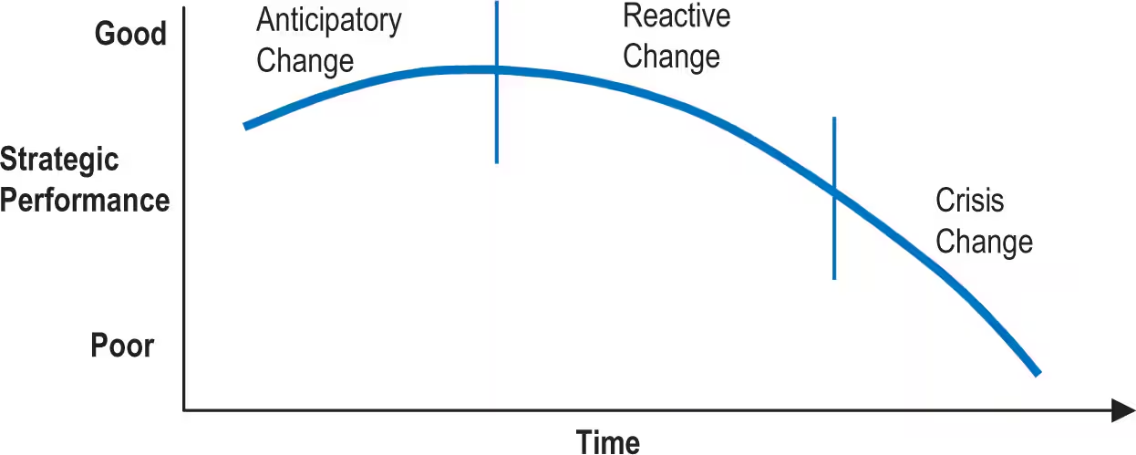

Urgency state: anticipatory
- Situation allows time to think it through and plan
  - Result from uncertainties facing the business in the future
    - Limited perceived urgency, considerable obstacle to change
- Management issues
  - Ambiguity of anticipatory situation
    - Problem is simply not that clear
    - Limited ability to prove that change is necessary
  - Lack of a sense of urgency for change
  - Personal credibility
- Pepsi

Urgency state: reactive
- The need for change is becoming increasingly clear
  - Establish a tangible measure of urgency
- Management issues
  - Bring focus to the core business
    - Tremendous range of ideas being generated
  - Leadership
  - Need power to press for change
- S & N

Urgency state: crisis
- Requires fast, focused and decisive
  - Might be in vain if business already passed the point of no return!
- Management issues
  - Financials
    - Cash flows
    - Need to buy time
  - Depleted resources
    - People
    - Assets
    - Reputation
- Maple leaf foods, Volkswagen

Starting conditions organizational readiness
- Who is the most affected?
  - Are they ready for the proposed changes?
- Target group identification
  - Isolate a limited number of group targets
    - Critical to the first step of changes
    - Increase the precision of the actions
  - Broad & unfocused change programs run into problems
- Target group readiness
  - Two dimensions to be assessed
    - Sense of commitment
    - capability

target group readiness: sense of commitment
Factors
- unaware of the need for change
- downplay or deny the urgency of the situation
- agree with need for change but disagree with proposed direction
- resist for fear of losing status/power within job context
- deliberate passive resistance
  - compliance on the surface while foot dragging underneath

target group readiness: capability
- focus on specific individuals or groups that are critical to the proposed changes vs firm as a whole
- assess gaps between capability and requirements to support change
factors:
- options to address gaps varies depending on the state of urgency
  - anticipatory, reactive or crisis
- self-assess gaps may affect sense of commitment
  - increase state of denial
  - increase resistance

starting conditions: personal readiness
manager tasked to lead the implementation plan
- can they do it and be effective?

Two dimensions to be assessed:
- sense of commitment
- capability
** need to be assessed both from a personal and external perspective

step #3: establish guidelines for actions
guidelines for action: priority objectives
- first set of priorities should be given to items that require or are designed to produce behaviour change
- most difficult and challenging
guidelines for action: priority targets and actions
- within the priority groups, need to assess individuals and priority targets
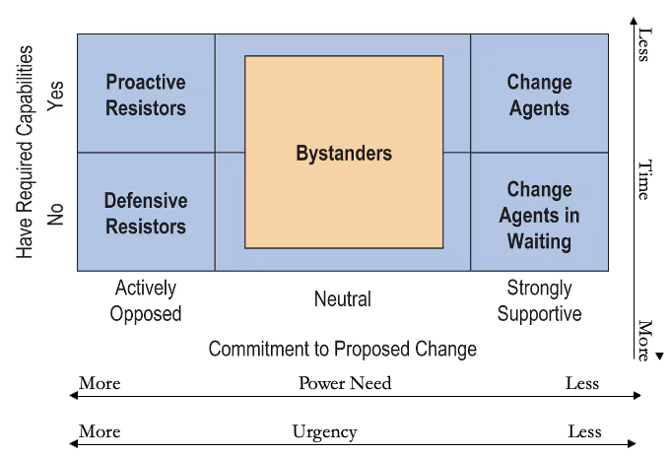
guidelines for action: leadership style
- directive or participative?

leadership style: directive
- characteristics: autocratic, command, coercive, top down
- assumptions: problem understood, solutions are known, power established to force compliance
- pros: can achieve change quickly
- cons: difficult to change course once engaged

leadership style: participative
- characteristics: bottom up, collaborative empowering, shared
- assumptions: effective diagnosis and remedy can be developed in the course of the change process
- pros: creates a buy-in to the changes and harnesses energy
- cons: change is slow
guidelines for action: pace
pace = amount of change in a given period of time
- scope and significane of the required changes
factors to consider in defining the pace of change
- urgency of the business situation
- personal urgency to implement the changes

step #4: create an action plan / implementation plan
time periods:
- recommended 90-day periods
- short and long term
establish priority targets and objectives for each period for each functional area:
- for each objective and target, identify specific actions
- determine how it will impact each area, R&D, sourcing, marketing, manufacturing, HR, finance, capital requirements, etc.
key points
- avoid temptation to do so much too quickly
- only so much management attention!
- Only so many financial resources
- Implementing change requires discipline and patience
key questions
- when? what to do first? Who will lead/do it
- how to make sure its working?
- How to align employee incentives?
- How to overcome resistance?
Format:
- Gantt charts
- Project management software
- Whatever works best for you

Class 19&20 - Corporate Strategy
Corporate strategy
- Companies that have business units across different industries
- Considers
  - What businesses and industries should we be operating in?
  - How should we manage these businesses
  - Is the corporate level adding value
  - What is the economic justification of the multi-business structure (from a shareholder perspective)?
- Considers whether a company can leverage its existing resources or develop new capabilities
- Determines whether there are opportunities for economies of scale/scope across the business units
- Considers best organizational structure
  - U form (unitary) vs M form (multidivisional)
- Considers how to manage organization
  - Leadership by division or centrally controlled
  - Financial or strategic or combination of both
- Considers how to reward performance
  - Divisional or corporate or both

Levels of strategy
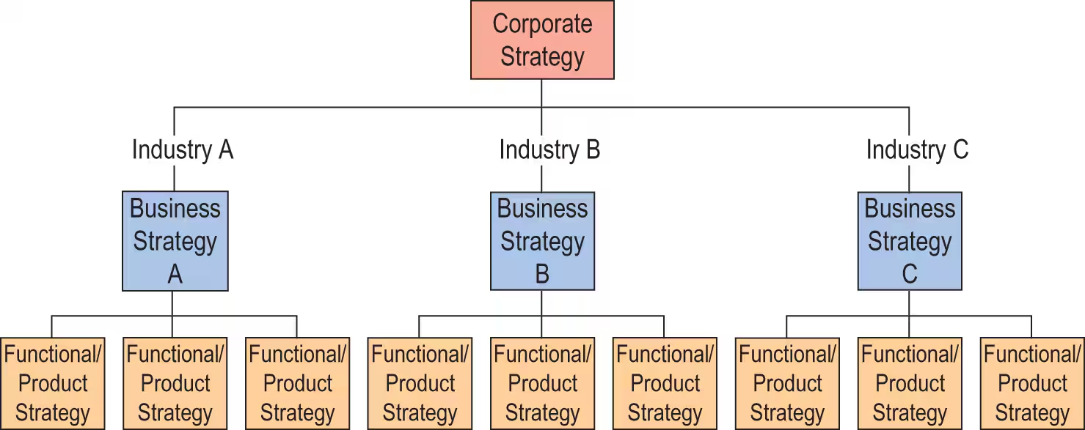
Corporate strategy
- What business should we be in?
- How should we organize?
- How should we distribute resources?
Business strategy
- How should compete/position ourselves vs others in our industry?
Functional product strategy
- How should we make/price/sell our products?

Describing a company’s corporate strategy
- Identify the businesses that the companies incorporate
  - Similarities and differences amongst them
- Identify the resources (financial, technical, personnel, R&D) that can be shared or transferred between businesses
- Identify how much corporate management is engaged in business-level decisions about strategy, operations, and performance

What is meant by diversification?
- A firm is diversified when it operates in two or more lines of business that are in distinctly different industries
- Diversification complicates the strategy-making task because it requires
  - Assessing the multiple industry environments for each BU
  - Developing a separate business strategy for each industry in which the diversified firm operates
  - Facing different gaps in each unit - which to address first
  - Requiring different incentives, perhaps even culture
  - Devising a companywide (or corporate) strategy for improving the attractiveness and performance of the company’s overall business lineup
  - Making a rational whole out of its diversified collection of individual businesses and individual business strategies

When to diversify?
- Conditions in the present industry turn sour and are expected to be long lasting
- There are opportunities to expand into industries whole technologies and products complement its present business
- A company’s present competencies and capabilities are key success factors and valuable competitive assets for competing in another business
- Diversifying into closely related businesses will reduce the company’s costs
- The company has a powerful and well-known brand name that can be transferred to the products of other businesses and help drive the sales and profits or such businesses to higher levels.

Do we need to diversify?
- Theres no urgency for a single business firm to diversify into other businesses so long as it has ample opportunities for growth and profitability in its present industry
- But it’s risky for a single business company to continue to keep all of its eggs in one industry basket when, for whatever reason, its prospects for continued good performance start to dim.

Diversification possibilities
- Diversifying into closely related or totally unrelated businesses
- Acquiring an existing firm in a business/industry it wants to enter
- Forming a new business subsidiary to enter a promising industry
- Forming joint ventures with other firms to enter new businesses

What does crafting a diversification strategy involve?
Strategy-making in a diversified firm requires:
- Picking new industries to enter and deciding whether to enter the industry by start-up, acquisition, or join venture or strategic alliance with another firm
- Initiating actions to boost the combined performance of the firm’s collection of businesses
- Pursuing opportunities to leverage cross-business value chain relationships and strategic fits into competitive advantage
- Evaluating the growth and profitability prospects for each business and then investing aggressively in the best prospects, investing cautiously in businesses with average prospects, and divesting businesses with unacceptable prospects

Diversification
Companies can be made up of
- Single business unit (Porter, cupcakes by Lizbeth)
- Dominant business unit (Lincoln Electric)
- Related constrained (Tesla - Batteries, Solar Power)
- Related linked (Tesla - SpaceX, Harlequin)
- Unrelated

Corporate strategy

- Single business unit
  - 95% or more of revenues come from one business unit
- Dominant business unit
  - 70% to less than 95% of revenue comes from one business unit and the corporation has other, much smaller business units
- Related constrained

- Related linked
- Unrelated

Strategies for pursuing diversification
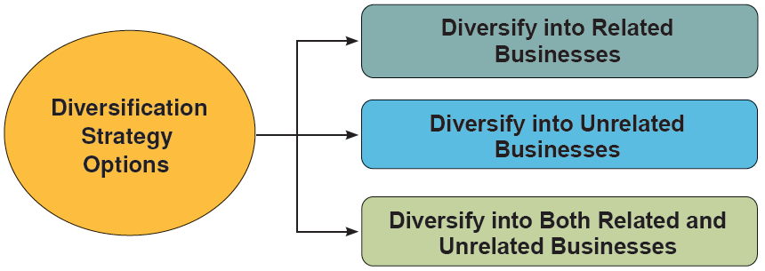
Related vs unrelated businesses
- Related
  - involves diversifying into businesses whose value chains possess competitively valuable “strategic fits” with the value chain(s) of the firm’s present business(es)
- unrelated
  - Involves diversifying into businesses having no competitively valuable value chain match-ups or strategic fits with the value chain(s) of the firm’s present businesses

Business case for diversifying into related businesses
- What makes related diversification an attractive strategy is the opportunity to convert cross-business strategic fits into a competitive advantage over business rivals whose operations do not offer comparable strategic fit benefits
- The greater the relatedness among a diversified company’s sister businesses, the bigger a company’s window for converting strategic fits into competitive advantage via:
  - Transfer of valuable expertise, technological know-how, or other resources from one business to another
  - The capture of cost-saving efficiencies along the value chains of related businesses
  - Cross-business use of a well-respected brand name
  - Cross-business collaboration to create competitively valuable resource strengths and capabilities / to learn

Economies of scope != economies of scale
Economies of scale are cost savings that occur because a large-scale operation is more cost-efficient than a small-scale operation
Economies of scope are achieved by capturing cost-saving strategic fits along the value chains of related businesses; examples of such cost-saving efficiencies include:
  - Production-related strategic fits that enable two or more related businesses to use the same manufacturing facility to perform their production activities
  - Distribution-related strategic fits that enable two or more related businesses to share use of the same distribution centers
  - Sales- and customer-related strategic fits that enable two or more related businesses to use a common sales force to sell their products to customers
  - The ability of two or more related businesses to share use of the same administrative infrastructure and thus spread admin costs over a bigger sales volume

Why achieving economies of scope in related businesses is competitively valuable
The greater the cost-savings associated with cost-related strategic fits among the value chains of sister businesses, the greater the potential for a related diversification strategy to yield a low-cost competitive advantage over:
- Undiversified competitors
- Competitors whose own diversification efforts do not offer equivalent cost-saving benefits

Related Constrained
- Less than 70 % of total corporate revenue comes from any one business unit!
- There is much ability to transfer core competencies among business units and to share activities among business units (R&D, Marketing, Distribution, Suppliers, etc.)
- As an example, Shoppers Drug Mart had 3 business units (Pharmacies, Front end, and Cosmetics) in its stores. Distribution and marketing are shared activities among the 3 business units.

Related Linked
- Less than 70 % of total corporate revenue comes from any one business unit.
- There is limited but some ability to transfer core competencies (e.g., managers) among business units and to share activities among business units (R&D, Marketing, Distribution, Suppliers, etc. ).
- Less opportunities for economies of scope

Unrelated diversification
- Less than 70 % of total corporate revenue comes from any one business unit
- Business units all in different industries
- There is very little to no ability to transfer core competencies (e.g., managers) among business units and to share activities among business units (R&D, Marketing, Distribution, Suppliers, etc. )
The basic premise of unrelated diversification is that any firm or business that can be acquired on good financial terms and that has satisfactory growth and earnings potential represents a good acquisition and a good business opportunity.

What is appealing about unrelated diversification?
- The firm’s profitability may be more stable in those situations where business risk is spread across industries whose market conditions do NOT grow stronger or weaker simultaneously
- In a broadly diversified company, there’s a chance that market downtrends in some of the company’s businesses will be partially offset by cyclical upswings in its other businesses, thus producing somewhat less earnings volatility
- For bargain-priced firms with upside profit potential, shareholder wealth can be enhanced by:
  - Buying distressed firms at a low price and turning their operations around quickly with infusions of cash and parent firm managerial know-how, then selling them at a profit

How to successfully manage unrelated diversified firms?
- Do a superior job of diversifying into new businesses that can produce good earnings and returns on investment
- Negotiate favorable acquisition prices
- Do such a good job of overseeing the firm’s business subsidiaries that the subsidiaries perform at a higher level than they would otherwise be able to do through their own efforts alone
- Identify when to shift resources out of businesses with dim prospects and into businesses with good prospects
- Discern when a business needs to be sold, and then selling it for a price higher than the firm’s net investment in the divested business, resulting in a capital gain for shareholders

Risk: mediocre performance (or worse!!)
- Without the added competitive advantage potential that cross-business strategic fit provides, it is hard for the consolidated performance of an unrelated group of businesses to be any better than the sum of what the individual business units could achieve if they were independent.

Related vs. unrelated diversification strategies
Relying solely on the expertise of corporate executives to astutely manage a set of unrelated businesses is a much weaker foundation for enhancing shareholder value than is a strategy of related diversification. A strategy of unrelated diversification is a riskier and more problematic approach to diversifying than is a strategy of related diversification.

Drawbacks of unrelated diversification

